






Prepare and cook poultry and game meats
D1.HCC.CL2.09
Trainer Guide

Prepare and cook poultry and game meats

D1.HCC.CL2.09

Trainer Guide




Project Base
William Angliss Institute of TAFE
555 La Trobe Street
Melbourne 3000 Victoria
Telephone: | (03) 9606 2111
Facsimile: | (03) 9670 1330
Acknowledgements
Project Director: | Wayne Crosbie
Chief Writer: | Alan Hickman
Subject Writer: | Garry Blackburn
Project Manager: | Alan Maguire
Editor: | Jim Irwin
DTP/Production: | Daniel Chee, Mai Vu, Jirayu Thangcharoensamut, Kaly Quach

The Association of Southeast Asian Nations (ASEAN) was established on 8 August 1967. The Member States of the Association are Brunei Darussalam, Cambodia, Indonesia, Lao PDR, Malaysia, Myanmar, Philippines, Singapore, Thailand and Viet Nam.
The ASEAN Secretariat is based in Jakarta, Indonesia.
General Information on ASEAN appears online at the ASEAN Website: www.asean.org.
All text is produced by William Angliss Institute of TAFE for the ASEAN Project on “Toolbox Development for Front Office, Food and Beverage Services and Food Production Divisions”.
This publication is supported by the Australian Government’s aid program through the ASEAN-Australia Development Cooperation Program Phase II (AADCP II).
Copyright: Association of Southeast Asian Nations (ASEAN) 2013.
All rights reserved.
Disclaimer
Every effort has been made to ensure that this publication is free from errors or omissions. However, you should conduct your own enquiries and seek professional advice before relying on any fact, statement or matter contained in this book. The ASEAN Secretariat and William Angliss Institute of TAFE are not responsible for any injury, loss or damage as a result of material included or omitted from this course. Information in this module is current at the time of publication. Time of publication is indicated in the date stamp at the bottom of each page.
Some images appearing in this resource have been purchased from stock photography suppliers Shutterstock and iStockphoto and other third party copyright owners and as such are non-transferable and non-exclusive. Clip arts, font images and illustrations used are from the Microsoft Office Clip Art and Media Library. Some images have been provided by and are the property of William Angliss Institute.
Additional images have been sourced from Flickr and SKC and are used under Creative Commons licence: http://creativecommons.org/licenses/by/2.0/deed.en
File name: TG_Prepare_&_cook_poultry_&_game_meats_FN_070114





Table of contents
Competency Based Training (CBT) and assessment - An introduction for trainers 1
Competency standard 11
Notes and PowerPoint slides 21
Cookery practical classes: Recommended training equipment 51
Instructions for Trainers for using PowerPoint – Presenter View 53
Appendix – ASEAN acronyms 55

Competency Based Training (CBT) and assessment - An introduction for trainers

Competency
Competency refers to the ability to perform particular tasks and duties to the standard of performance expected in the workplace.
Competency requires the application of specified knowledge, skills and attitudes relevant to effective participation, consistently over time and in the workplace environment.
The essential skills and knowledge are either identified separately or combined.
Knowledge identifies what a person needs to know to perform the work in an informed and effective manner.
Skills describe the application of knowledge to situations where understanding is converted into a workplace outcome.
Attitude describes the founding reasons behind the need for certain knowledge or why skills are performed in a specified manner.
Competency covers all aspects of workplace performance and involves:
- Performing individual tasks
- Managing a range of different tasks
- Responding to contingencies or breakdowns
- Dealing with the responsibilities of the workplace
- Working with others.

Unit of Competency
Like with any training qualification or program, a range of subject topics are identified that focus on the ability in a certain work area, responsibility or function.
Each manual focuses on a specific unit of competency that applies in the hospitality workplace.
In this manual a unit of competency is identified as a ‘unit’.
Each unit of competency identifies a discrete workplace requirement and includes:
- Knowledge and skills that underpin competency
- Language, literacy and numeracy
- Occupational health and safety requirements.
Each unit of competency must be adhered to in training and assessment to ensure consistency of outcomes.

Element of Competency
An element of competency describes the essential outcomes within a unit of competency.
The elements of competency are the basic building blocks of the unit of competency. They describe in terms of outcomes the significant functions and tasks that make up the competency.
In this manual elements of competency are identified as an ‘element’.

Performance criteria
Performance criteria indicate the standard of performance that is required to demonstrate achievement within an element of competency. The standards reflect identified industry skill needs.
Performance criteria will be made up of certain specified skills, knowledge and attitudes.

Learning
For the purpose of this manual learning incorporates two key activities:
- Training
- Assessment.
Both of these activities will be discussed in detail in this introduction.
Today training and assessment can be delivered in a variety of ways. It may be provided to participants:
- On-the-job – in the workplace
- Off-the-job – at an educational institution or dedicated training environment
- As a combination of these two options.
No longer is it necessary for learners to be absent from the workplace for long periods of time in order to obtain recognised and accredited qualifications.

Learning Approaches
This manual will identify two avenues to facilitate learning:
Competency Based Training (CBT)
This is the strategy of developing a participant’s competency.
Educational institutions utilise a range of training strategies to ensure that participants are able to gain the knowledge and skills required for successful:
- Completion of the training program or qualification
- Implementation in the workplace.
The strategies selected should be chosen based on suitability and the learning styles of participants.

Competency Based Assessment (CBA)
This is the strategy of assessing competency of a participant.
Educational institutions utilise a range of assessment strategies to ensure that participants are assessed in a manner that demonstrates validity, fairness, reliability, flexibility and fairness of assessment processes.

Flexibility in Learning
It is important to note that flexibility in training and assessment strategies is required to meet the needs of participants who may have learning difficulties. The strategies used will vary, taking into account the needs of individual participants with learning difficulties. However they will be applied in a manner which does not discriminate against the participant or the participant body as a whole.
Catering for Participant Diversity
Participants have diverse backgrounds, needs and interests. When planning training and assessment activities to cater for individual differences, trainers and assessors should:
- Consider individuals’ experiences, learning styles and interests
- Develop questions and activities that are aimed at different levels of ability
- Modify the expectations for some participants
- Provide opportunities for a variety of forms of participation, such as individual, pair and small group activities
- Assess participants based on individual progress and outcomes.
The diversity among participants also provides a good reason for building up a learning community in which participants support each other’s learning.
Participant Centred Learning
This involves taking into account structuring training and assessment that:
- Builds on strengths – Training environments need to demonstrate the many positive features of local participants (such as the attribution of academic success to effort, and the social nature of achievement motivation) and of their trainers (such as a strong emphasis on subject disciplines and moral responsibility). These strengths and uniqueness of local participants and trainers should be acknowledged and treasured
- Acknowledges prior knowledge and experience – The learning activities should be planned with participants’ prior knowledge and experience in mind
- Understands learning objectives – Each learning activity should have clear learning objectives and participants should be informed of them at the outset. Trainers should also be clear about the purpose of assignments and explain their significance to participants
- Teaches for understanding – The pedagogies chosen should aim at enabling participants to act and think flexibly with what they know
- Teaches for independent learning – Generic skills and reflection should be nurtured through learning activities in appropriate contexts of the curriculum. Participants should be encouraged to take responsibility for their own learning
- Enhances motivation – Learning is most effective when participants are motivated. Various strategies should be used to arouse the interest of participants
- Makes effective use of resources – A variety of teaching resources can be employed as tools for learning
- Maximises engagement – In conducting learning activities, it is important for the minds of participants to be actively engaged
- Aligns assessment with learning and teaching – Feedback and assessment should be an integral part of learning and teaching
- Caters for learner diversity – Trainers should be aware that participants have different characteristics and strengths and try to nurture these rather than impose a standard set of expectations.
Active Learning
The goal of nurturing independent learning in participants does not imply that they always have to work in isolation or solely in a classroom. On the contrary, the construction of knowledge in tourism and hospitality studies can often best be carried out in collaboration with others in the field. Sharing experiences, insights and views on issues of common concern, and working together to collect information through conducting investigative studies in the field (active learning) can contribute a lot to their eventual success.
Active learning has an important part to play in fostering a sense of community in the class. First, to operate successfully, a learning community requires an ethos of acceptance and a sense of trust among participants, and between them and their trainers. Trainers can help to foster acceptance and trust through encouragement and personal example, and by allowing participants to take risks as they explore and articulate their views, however immature these may appear to be. Participants also come to realise that their classmates (and their trainers) are partners in learning and solving.
Trainers can also encourage cooperative learning by designing appropriate group learning tasks, which include, for example, collecting background information, conducting small-scale surveys, or producing media presentations on certain issues and themes. Participants need to be reminded that, while they should work towards successful completion of the field tasks, developing positive peer relationships in the process is an important objective of all group work.

Competency Based Training (CBT)
Principle of Competency Based Training
Competency based training is aimed at developing the knowledge, skills and attitudes of participants, through a variety of training tools.
Training Strategies
The aims of this curriculum are to enable participants to:
- Undertake a variety of subject courses that are relevant to industry in the current environment
- Learn current industry skills, information and trends relevant to industry
- Learn through a range of practical and theoretical approaches
- Be able to identify, explore and solve issues in a productive manner
- Be able to become confident, equipped and flexible managers of the future
- Be ‘job ready’ and a valuable employee in the industry upon graduation of any qualification level.
To ensure participants are able to gain the knowledge and skills required to meet competency in each unit of competency in the qualification, a range of training delivery modes are used.
Types of Training
In choosing learning and teaching strategies, trainers should take into account the practical, complex and multi-disciplinary nature of the subject area, as well as their participant’s prior knowledge, learning styles and abilities.
Training outcomes can be attained by utilising one or more delivery methods:
Lecture/Tutorial
This is a common method of training involving transfer of information from the trainer to the participants. It is an effective approach to introduce new concepts or information to the learners and also to build upon the existing knowledge. The listener is expected to reflect on the subject and seek clarifications on the doubts.
Demonstration
Demonstration is a very effective training method that involves a trainer showing a participant how to perform a task or activity. Through a visual demonstration, trainers may also explain reasoning behind certain actions or provide supplementary information to help facilitate understanding.
Group Discussions
Brainstorming in which all the members in a group express their ideas, views and opinions on a given topic. It is a free flow and exchange of knowledge among the participants and the trainer. The discussion is carried out by the group on the basis of their own experience, perceptions and values. This will facilitate acquiring new knowledge. When everybody is expected to participate in the group discussion, even the introverted persons will also get stimulated and try to articulate their feelings.
The ideas that emerge in the discussions should be noted down and presentations are to be made by the groups. Sometimes consensus needs to be arrived at on a given topic. Group discussions are to be held under the moderation of a leader guided by the trainer. Group discussion technique triggers thinking process, encourages interactions and enhances communication skills.
Role Play
This is a common and very effective method of bringing into the classroom real life situations, which may not otherwise be possible. Participants are made to enact a particular role so as to give a real feel of the roles they may be called upon to play. This enables participants to understand the behaviour of others as well as their own emotions and feelings. The instructor must brief the role players on what is expected of them. The role player may either be given a ready-made script, which they can memorize and enact, or they may be required to develop their own scripts around a given situation. This technique is extremely useful in understanding creative selling techniques and human relations. It can be entertaining and energizing and it helps the reserved and less literate to express their feelings.

Simulation Games
When trainees need to become aware of something that they have not been conscious of, simulations can be a useful mechanism. Simulation games are a method based on "here and now" experience shared by all the participants. The games focus on the participation of the trainees and their willingness to share their ideas with others. A "near real life" situation is created providing an opportunity to which they apply themselves by adopting certain behaviour. They then experience the impact of their behaviour on the situation. It is carried out to generate responses and reactions based on the real feelings of the participants, which are subsequently analysed by the trainer.
While use of simulation games can result in very effective learning, it needs considerable trainer competence to analyse the situations.
Individual /Group Exercises
Exercises are often introduced to find out how much the participant has assimilated. This method involves imparting instructions to participants on a particular subject through use of written exercises. In the group exercises, the entire class is divided into small groups, and members are asked to collaborate to arrive at a consensus or solution to a problem.
Case Study
This is a training method that enables the trainer and the participant to experience a real life situation. It may be on account of events in the past or situations in the present, in which there may be one or more problems to be solved and decisions to be taken. The basic objective of a case study is to help participants diagnose, analyse and/or solve a particular problem and to make them internalize the critical inputs delivered in the training. Questions are generally given at the end of the case study to direct the participants and to stimulate their thinking towards possible solutions. Studies may be presented in written or verbal form.
Field Visit
This involves a carefully planned visit or tour to a place of learning or interest. The idea is to give first-hand knowledge by personal observation of field situations, and to relate theory with practice. The emphasis is on observing, exploring, asking questions and understanding. The trainer should remember to brief the participants about what they should observe and about the customs and norms that need to be respected.
Group Presentation
The participants are asked to work in groups and produce the results and findings of their group work to the members of another sub-group. By this method participants get a good picture of each other's views and perceptions on the topic and they are able to compare them with their own point of view. The pooling and sharing of findings enriches the discussion and learning process.
Practice Sessions
This method is of paramount importance for skills training. Participants are provided with an opportunity to practice in a controlled situation what they have learnt. It could be real life or through a make-believe situation.

Games
This is a group process and includes those methods that involve usually fun-based activity, aimed at conveying feelings and experiences, which are everyday in nature, and applying them within the game being played. A game has set rules and regulations, and may or may not include a competitive element. After the game is played, it is essential that the participants be debriefed and their lessons and experiences consolidated by the trainer.
Research
Trainers may require learners to undertake research activities, including online research, to gather information or further understanding about a specific subject area.

Competency Based Assessment (CBA)
Principle of Competency Based Assessment
Competency based assessment is aimed at compiling a list of evidence that shows that a person is competent in a particular unit of competency.
Competencies are gained through a multitude of ways including:
- Training and development programs
- Formal education
- Life experience
- Apprenticeships
- On-the-job experience
- Self-help programs.
All of these together contribute to job competence in a person. Ultimately, assessors and participants work together, through the ‘collection of evidence’ in determining overall competence.
This evidence can be collected:
- Using different formats
- Using different people
- Collected over a period of time.
The assessor who is ideally someone with considerable experience in the area being assessed, reviews the evidence and verifies the person as being competent or not.
Flexibility in Assessment
Whilst allocated assessment tools have been identified for this subject, all attempts are made to determine competency and suitable alternate assessment tools may be used, according to the requirements of the participant.
The assessment needs to be equitable for all participants, taking into account their cultural and linguistic needs.
Competency must be proven regardless of:
- Language
- Delivery Method
- Assessment Method.
Assessment Objectives
The assessment tools used for subjects are designed to determine competency against the ‘elements of competency’ and their associated ‘performance criteria’.
The assessment tools are used to identify sufficient:
- Knowledge, including underpinning knowledge
- Skills
- Attitudes
Assessment tools are activities that trainees are required to undertake to prove participant competency in this subject.
All assessments must be completed satisfactorily for participants to obtain competence in this subject. There are no exceptions to this requirement, however, it is possible that in some cases several assessment items may be combined and assessed together.
Types of Assessment
Allocated Assessment Tools
There are a number of assessment tools that are used to determine competency in this subject:
- Work projects
- Written questions
- Oral questions
- Third Party Report
- Observation Checklist.
Instructions on how assessors should conduct these assessment methods are explained in the Assessment Manuals.
Alternative Assessment Tools
Whilst this subject has identified assessment tools, as indicated above, this does not restrict the assessor from using different assessment methods to measure the competency of a participant.
Evidence is simply proof that the assessor gathers to show participants can actually do what they are required to do.
Whilst there is a distinct requirement for participants to demonstrate competency, there are many and diverse sources of evidence available to the assessor.
Ongoing performance at work, as verified by a supervisor or physical evidence, can count towards assessment. Additionally, the assessor can talk to customers or work colleagues to gather evidence about performance.
A range of assessment methods to assess competency include:
- Practical demonstrations
- Practical demonstrations in simulated work conditions
- Problem solving
- Portfolios of evidence
- Critical incident reports
- Journals
- Oral presentations
- Interviews
- Videos
- Visuals: slides, audio tapes
- Case studies
- Log books
- Projects
- Role plays
- Group projects
- Group discussions
- Examinations.
Recognition of Prior Learning
Recognition of Prior Learning is the process that gives current industry professionals who do not have a formal qualification, the opportunity to benchmark their extensive skills and experience against the standards set out in each unit of competency/subject.
Also known as a Skills Recognition Audit (SRA), this process is a learning and assessment pathway which encompasses:
- Recognition of Current Competencies (RCC)
- Skills auditing
- Gap analysis and training
- Credit transfer.
Assessing competency
As mentioned, assessment is the process of identifying a participant’s current knowledge, skills and attitudes sets against all elements of competency within a unit of competency. Traditionally in education, grades or marks were given to participants, dependent on how many questions the participant successfully answered in an assessment tool.
Competency based assessment does not award grades, but simply identifies if the participant has the knowledge, skills and attitudes to undertake the required task to the specified standard.
Therefore, when assessing competency, an assessor has two possible results that can be awarded:
- Pass Competent (PC)
- Not Yet Competent (NYC).
Pass Competent (PC)
If the participant is able to successfully answer or demonstrate what is required, to the expected standards of the performance criteria, they will be deemed as ‘Pass Competent’ (PC).
The assessor will award a ‘Pass Competent’ (PC) if they feel the participant has the necessary knowledge, skills and attitudes in all assessment tasks for a unit.
Not Yet Competent’ (NYC)
If the participant is unable to answer or demonstrate competency to the desired standard, they will be deemed to be ‘Not Yet Competent’ (NYC).
This does not mean the participant will need to complete all the assessment tasks again. The focus will be on the specific assessment tasks that were not performed to the expected standards.
The participant may be required to:
a) Undertake further training or instruction
b) Undertake the assessment task again until they are deemed to be ‘Pass Competent’.

Competency standard
UNIT TITLE: PREPARE AND COOK POULTRY AND GAME MEATS |  |  |  | NOMINAL HOURS: 30
UNIT NUMBER: D1.HCC.CL2.09
UNIT DESCRIPTOR: This unit deals with skills and knowledge required by cooks and chefs to identify, prepare, cook, present and store a variety of poultry and game meats in commercial food production environments
ELEMENTS AND PERFORMANCE CRITERIA | UNIT VARIABLE AND ASSESSMENT GUIDE
Element 1: Identify and select poultry and game meats  - Identify varieties of poultry and game  - Identify commercial establishment cuts and specifications  - Identify and select suppliers for purchasing of products  - Minimise wastage through freshness and correct purchasing  - Identify costs through yield testing  - Ensure correct conditions are maintained for freshness and quality  Element 2: Prepare poultry and game meats  - Prepare and portion poultry and game meat cuts, to enterprise requirements  - Minimise wastage through preparation and storage | Unit Variables  The Unit Variables provide advice to interpret the scope and context of this unit of competence, allowing for differences between enterprises and workplaces. It relates to the unit as a whole and facilitates holistic assessment.  This unit applies to all industry sectors that prepare and cook poultry and game meat dishes within the labour divisions of the hotel and travel industries and may include:  - Food Production.  Varieties may include:  Feathered, such as chicken, duck, quail and turkey  Furred, such as venison, rabbit and boar  Scaled, such as snake and crocodile  Cultural varieties, such as local, indigenous bird or game.  Establishment cuts may be related to:  Menu needs  Service styles  Cookery methods
- Use of trimmings and leftovers  - Identification and use of equipment | Portion control  Trimmings, usage.
Element 3: Cook, hold and present  - Select appropriate cooking method for poultry and game meats  - Prepare and cook a selection of dishes following a standard recipes within a commercial environment  - Hold prepared products as required prior to presenting  - Present poultry and game meats  - Prepare garnishes, sauces and accompaniments for poultry and game meat dishes  Element 4: Store poultry and game products  - Fresh and/or vacuum packed items are stored correctly  - Prepare and maintain correct thawing of poultry and game  - Poultry and game is appropriately stored in correct containers  - Poultry and game is correctly labelled  - Ensure correct conditions are maintained for freshness and quality | Select suppliers may be related to:  Local, regional and international supply  Delivery requirements  Cost and trading terms  Relationship  Product range/variety  Availability  Cultural festivals.  Minimise wastage should include:  Storage space  Volume requirements, such as a la carte, functions and specials  First In, First Out (FIFO)  Receiving times, as needed  Quality, such as appearance, age and size.  Yield testing may include:  Filleting and skinning  Portion weights  Off cut usage  Staff skills.
Correct conditions should include:
Temperature and humidity
Stock rotation
Reporting faults
Changing containers
Cross contamination, such as handling.
Prepare and portion should relate to:
De-feather, skin, fillet and hang
Slice, dice, skewer, smoke, marinate, pickle, truss, lard and bard (cover meat with fat to avoid it drying out while cooking)
Cut and trim, including whole, fillet and cutlet
Portion control, enterprise weights.
Preparation and storage may include:
Cut and trim
Containers
Service styles
Stock rotation, first in, first out
Temperature control.
Trimmings may relate to:
Off cuts, usage
Saleable dishes
Menu varieties.
Equipment may include:
Electric, gas or induction stoves
Steamers, such as pressure, atmospheric, bamboo and fish kettle
Salamanders
Smokers
Grills, such as flat top, char and BBQ
Ovens, convection ovens and combination ovens
Deep fry, pressure fryer
Microwave
Food processors, mixers, mincers and bowl choppers
Enterprise and manufacturer’s instructions.
Cooking method may relate to:
Poaching
Steaming
Boiling
Grilling
Baking
Roasting
Braising
Stewing
Deep and shallow frying
Cultural style.
Prepare should relate to:
Cleaning, skinning and trimming
Cutting of ingredients/flavourings
Portioning, wastage and timing
Recipe conversions.
Hold may relate to:
Resting, portioning and cutting
Holding equipment
Cooling procedures
Hygiene practice.
Present should include:
Colour
Height
Texture
Service and storage temperature
Ceramics
Glass
Crystal
Mirrors
Trays
Classical and cultural aspect
Neatly and attractively
Ease of service.
Garnishes, sauces and accompaniments may include:
Glazing
Coating
Colour and flavour blends
Cultural flavours
Flowers and leaves
Pastry
Sauces, sweet/savoury
Dietary and cultural styles/flavours.
Stored correctly may include:
Cool room temperature
Cool room placement
Length of time in cool storage
Freezer temperature
Length of time in freezer storage
Appropriate process followed, vacuum packed, ice packed.
Thawing may relate to:
Enterprise and local authority requirements
Handling and cool room placement
Changing containers.
Stored must include:
Storage containers before assembly
Storage containers after assembly
Dietary and cultural styles/flavours
Labelled
Freshness, quality and presentation
Temperature and humidity.
Labelled must include:
Date
Item name
Handler name
Time, temperature and storage.
Assessment Guide
The following skills and knowledge must be assessed as part of this unit:
Knowledge of correct method is demonstrated for poultry and game
Ability to identify food products by sight
Ability to match ingredient quality to intended final product/use
Overview of the relevant legislation in relation to food handling, food storage, chemical storage and general premises food safety
Ability to demonstrate safe knife handling skills to industry and enterprise standards
Ability to demonstrate safe equipment/utensil practical skills
Ability to interpret and adhere to enterprise recipes.
Linkages To Other Units
Comply with workplace hygiene procedures
Implement occupational health and safety procedures
Prepare and store food
Work effectively with colleagues and customers
Maintain strategies for safe food
Present and display food products
Apply basic techniques of commercial cookery.
Critical Aspects of Assessment
Evidence of the following is essential:
Knowledge of the classifications and characteristics of poultry and game and the terminology used
Demonstrate safe and hygienic handling of products
Appropriate portion control and wastage
Demonstrate complimentary presentation, garnishing and techniques
Demonstrate safe knife skills and other associated equipment
Demonstration of commodity knowledge, including quality aspects
Knowledge of specific terminology related to various poultry and game products
Demonstrated ability to prepare various poultry and game dishes from at least six different recipes and cultural backgrounds
Demonstrated ability to store various poultry and game dishes to industry and enterprise standards
Knowledge of appropriate portion control and wastage.
Context of Assessment
This unit may be assessed on or off the job:
Assessment should include practical demonstration either in the workplace or through a simulation activity, supported by a range of methods to assess underpinning knowledge
Assessment must relate to the individuals work area or area of responsibility
Demonstration of skills on more than one occasion
Preparation of various poultry and game dishes within typical workplace conditions and timeframes.
Resource Implications
Training and assessment must include access and use of a fully equipped commercial kitchen, real ingredients and service equipment; and access to workplace standards, procedures, policies, guidelines, tools and equipment.
Assessment Methods
The following methods may be used to assess competency for this unit:
Observation of practical candidate performance
Oral and written questions
Third party reports completed by a supervisor
Project and assignment work
Sampling of dishes prepared by the student.
Key Competencies in this Unit
Level 1 = competence to undertake tasks effectively
Level 2 = competence to manage tasks
Level 3 = competence to use concepts for evaluating
 | Key Competencies | Level | Examples
 | Collecting, organising and analysing information | 2 | Determine requirements of standard recipes and/or menu requirements; collect equipment, commodities and ingredients, read menus, recipes and task sheets; select and obtain commodities, organise ingredients and task sheets
 | Communicating ideas and information | 2 | Share information with other kitchen and floor service staff; read recipes, menus and instructions and orders
 | Planning and organising activities | 2 | Work within time constraints in a logical sequence; plan logical and efficient sequence and timing of tasks
 | Working with others and in teams | 1 | Work cooperatively with other team members
 | Using mathematical ideas and techniques | 1 | Calculate portions, weigh and measure quantities against standard recipes and/or menu requirements
 | Solving problems | 1 | Identify and correct problems in the preparation and production of products, such as ingredient quality and equipment failure
 | Using technology | 1 | Use mechanical kitchen equipment, including weighing equipment

Notes and PowerPoint slides
Slide
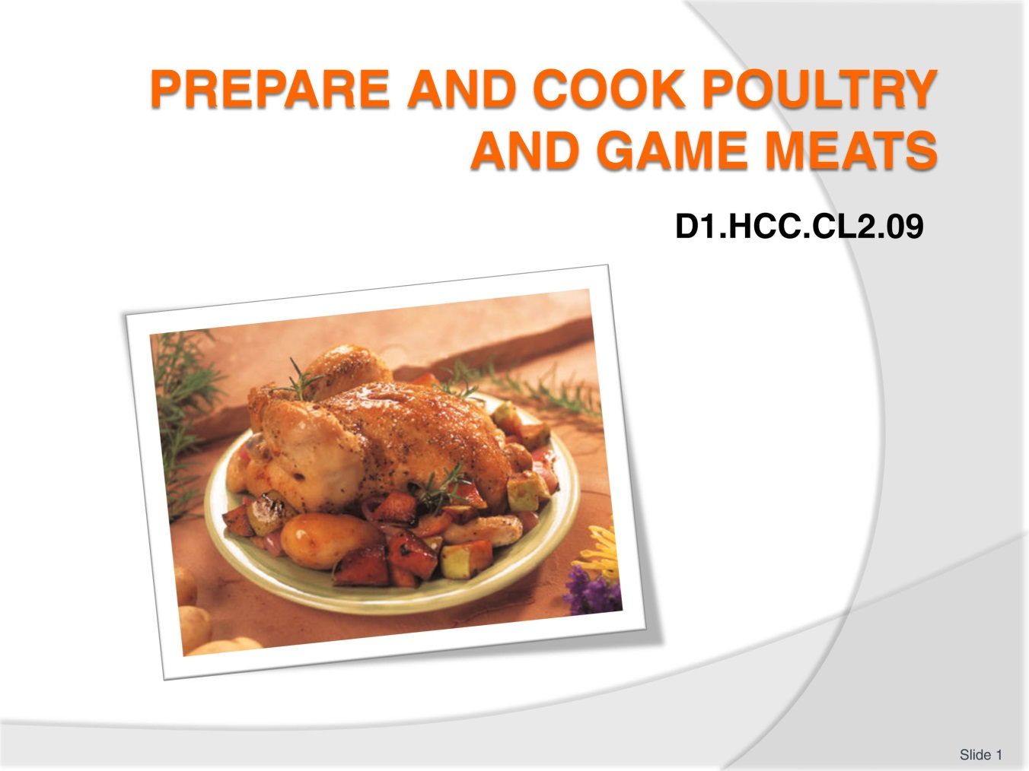
Slide No | Trainer Notes
 | Trainer to welcome students to class

Slide
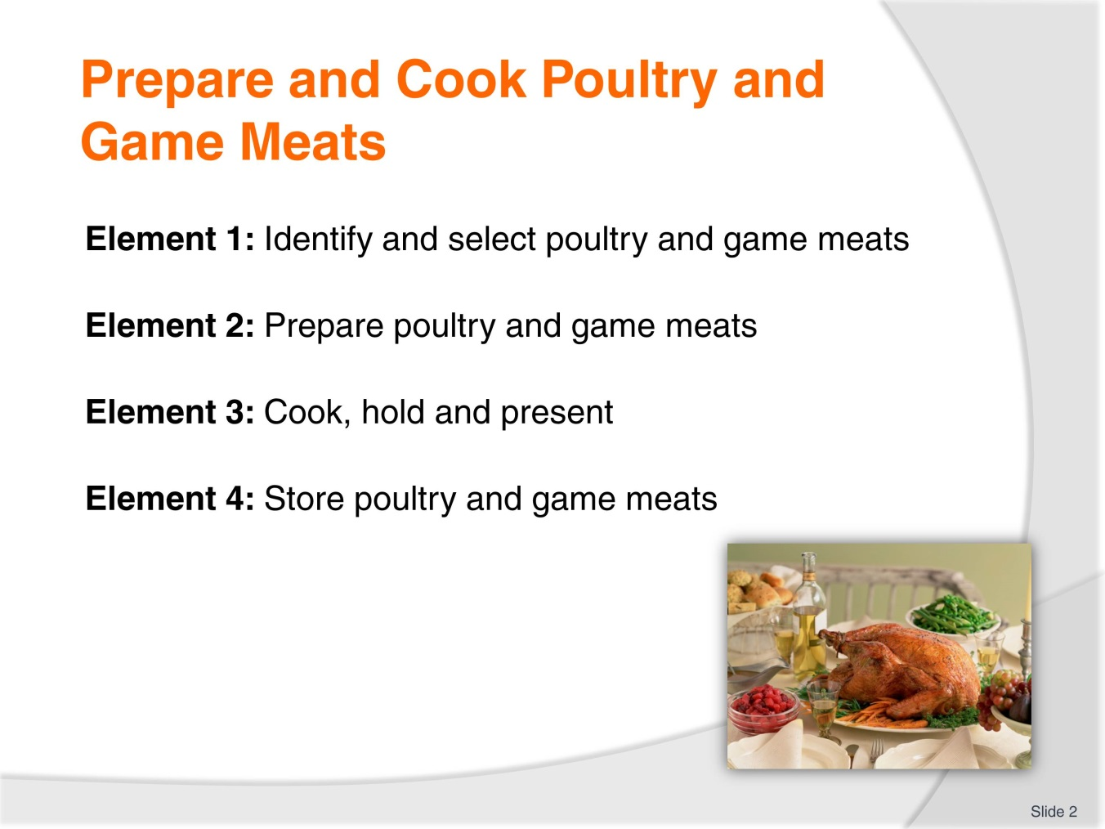
Slide No | Trainer Notes
Trainer advises students this Unit comprises four Elements, as listed on the slide explaining:
Each Element comprises a number of Performance Criteria which will be identified throughout the class and explained in detail
Students can obtain more detail from their Trainee Manual
The course presents advice and information but where their workplace requirements differ to what is presented, the workplace practices and standards must be observed.

Slide
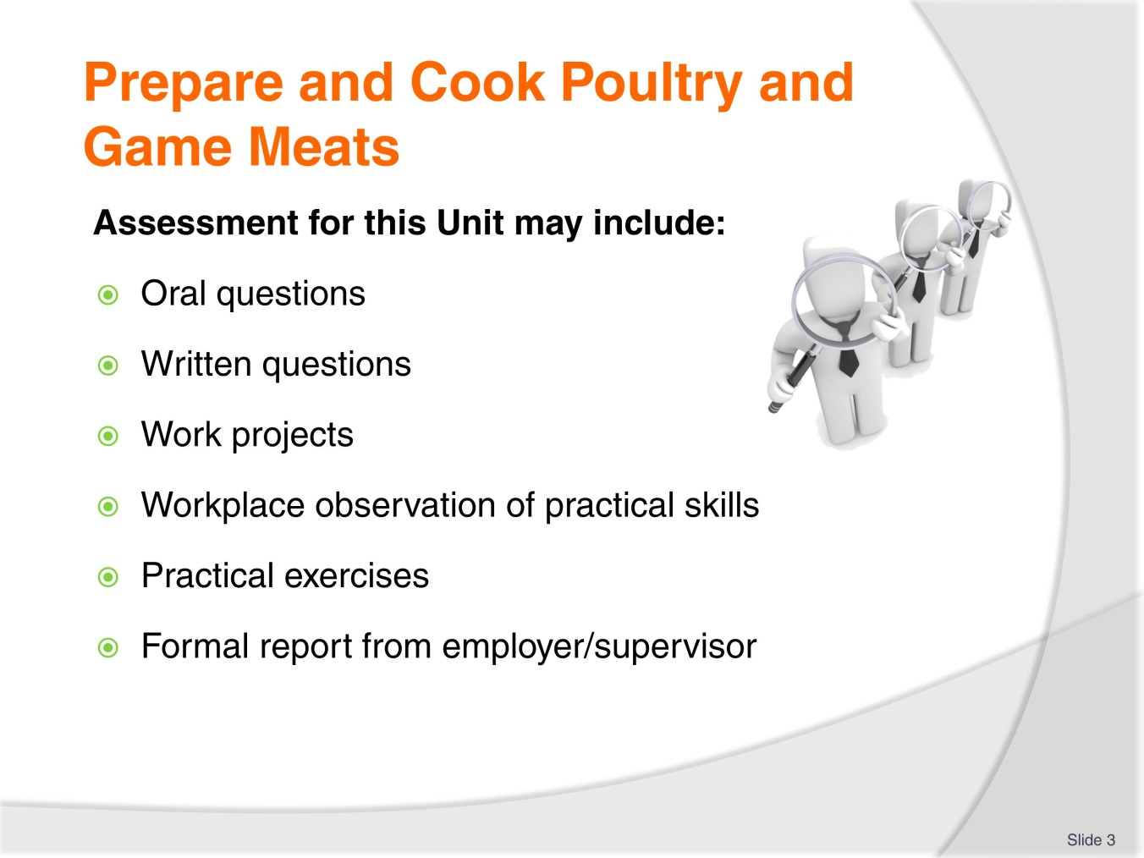
Slide No | Trainer Notes
Trainer advises students that assessment for this Unit may take several forms all of which are aimed at verifying they have achieved competency for the Unit as required.
Trainer indicates to students the methods of assessment that will be applied to them for this Unit.

Slide
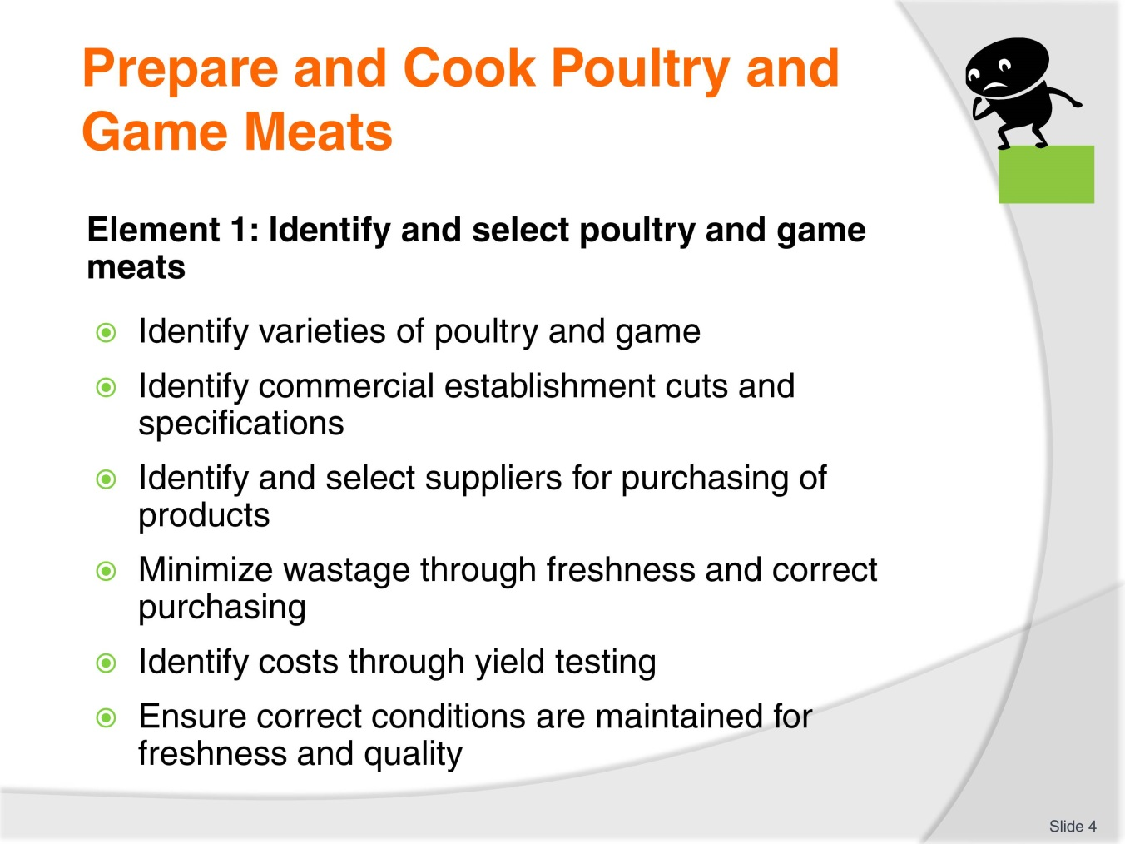
Slide No | Trainer Notes
Trainer to discuss performance criteria required tor Element 1
The element is the skill
To assess competency in the skill; the performance criteria is used to outline activities that can be used to assess competency.
The trainer should relate how the performance criteria is related to the element
To prove competency in Prepare and Cook poultry game meats the student has to be able to; Identify and select poultry and game meats
The students need to be able to:
Identify different varieties of poultry and game
Identify commercial establishment cuts and defined specifications
Identify and select supplier to supply enterprise with commodities
Minimise wastage through fresh and correct purchasing
Identify costs through yield testing
Ensure correct conditions are maintained for freshness and quality.

Slide
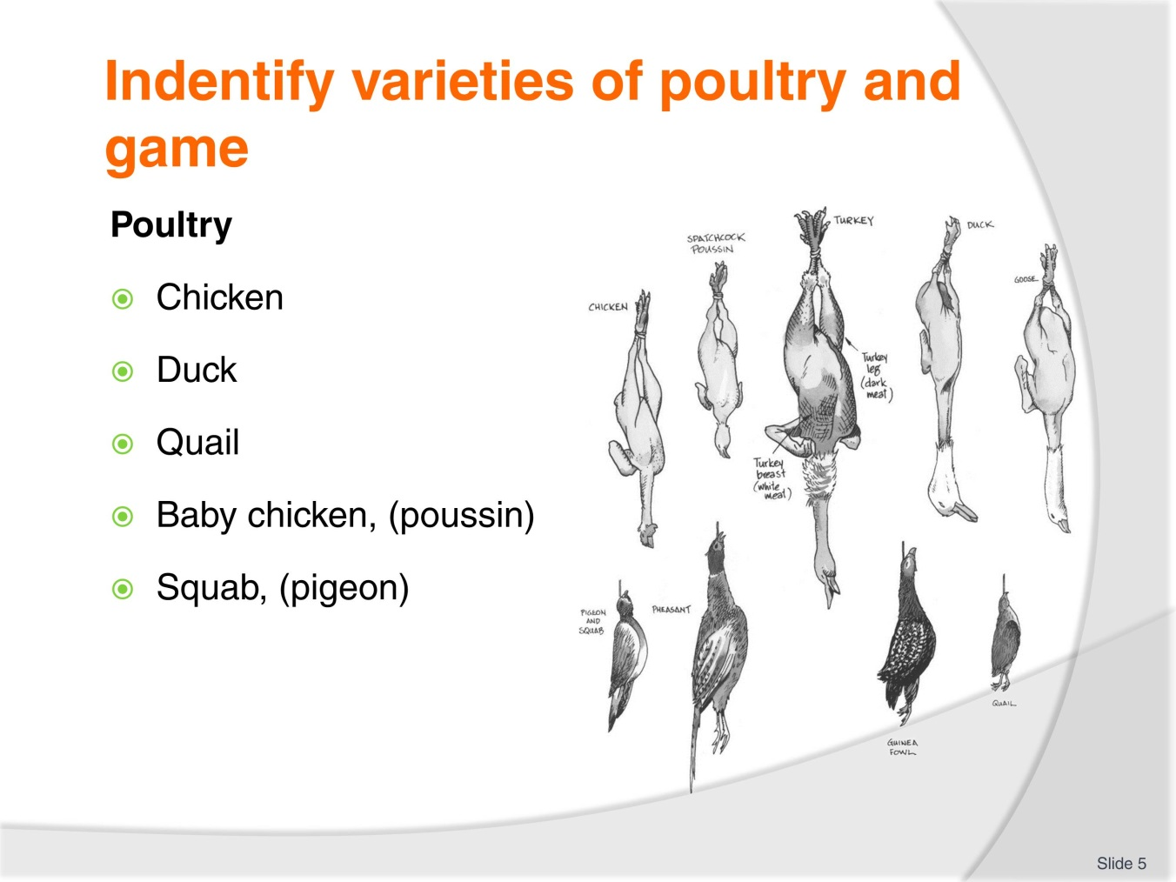
Slide No | Trainer Notes
Trainer to discuss points relative to the ‘normal’ poultry that is found in the country in which this program is being delivered.
Activity: Get the students to discuss what type of poultry that they see in the marketplace.
Define poultry as something that is available all the time.
Special poultry is only eaten on special occasions.
Wild game birds have to be hunted for, not grown by a business.

Slide
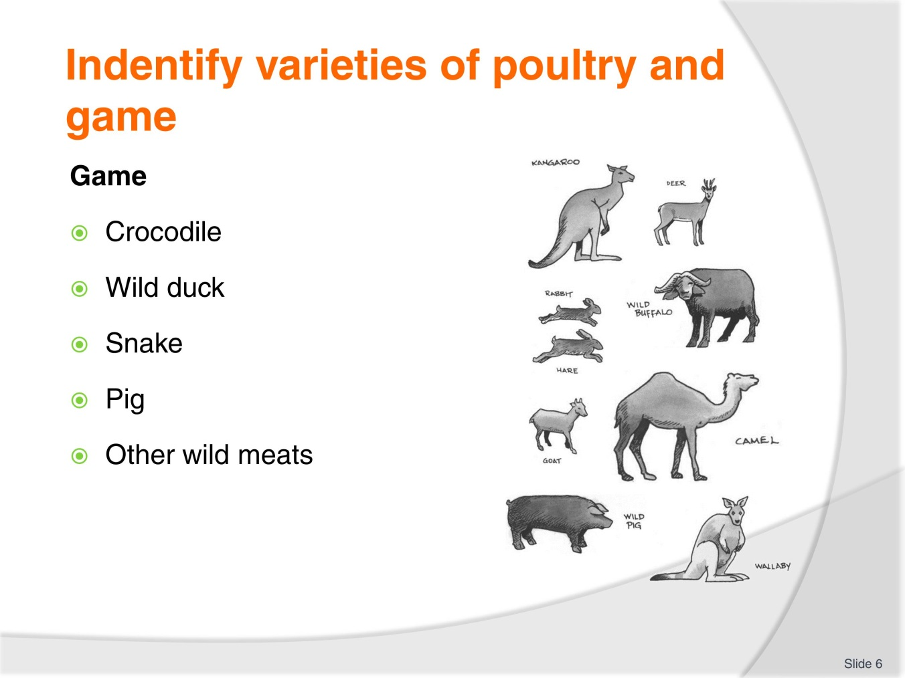
Slide No | Trainer Notes
Trainer to discuss what is considered ‘game’ in the country that this unit is being delivered.
Game: wild birds and animals that are not normally grown for human consumption, need to be hunted.
It will vary from country to country.
Activity: Get the students to discuss what they can see in the marketplace that is commonly available to the restaurant industry as ‘GAME”. It will vary from country to country.
Is it safe to consume? Is it legal?

Slide
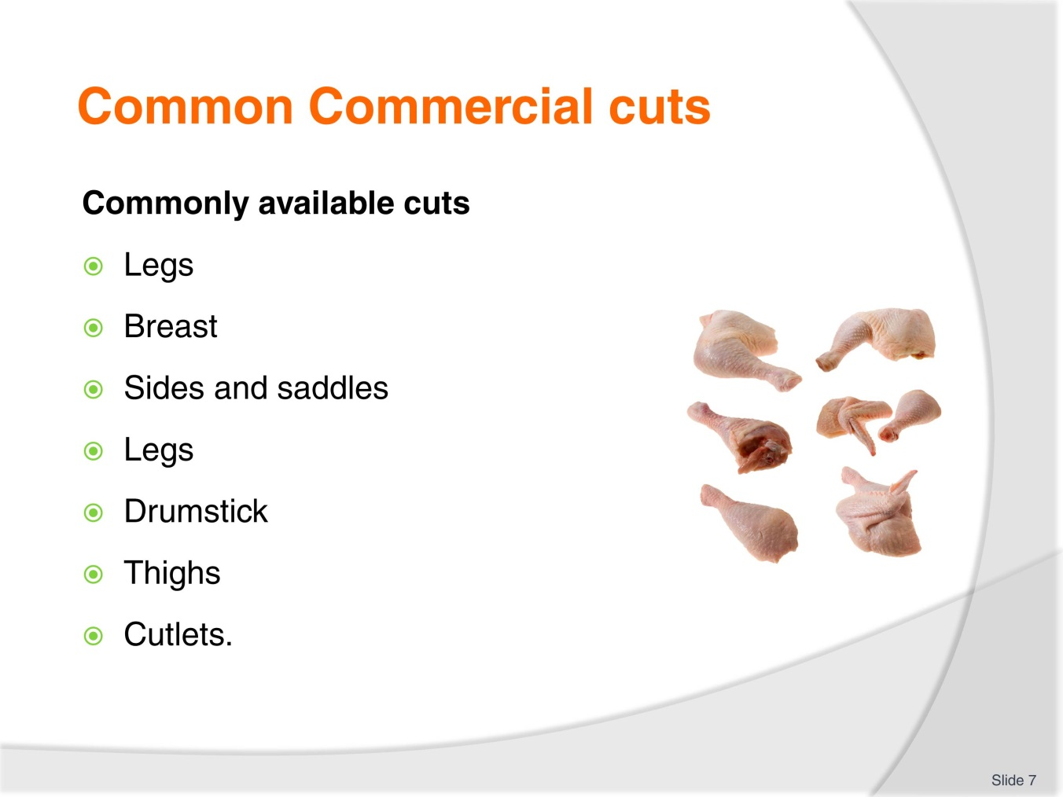
Slide No | Trainer Notes
Trainer to discuss:
What is commonly available in the local market place?
Changing and emerging trends locally
Changing and emerging trends overseas.

Slide
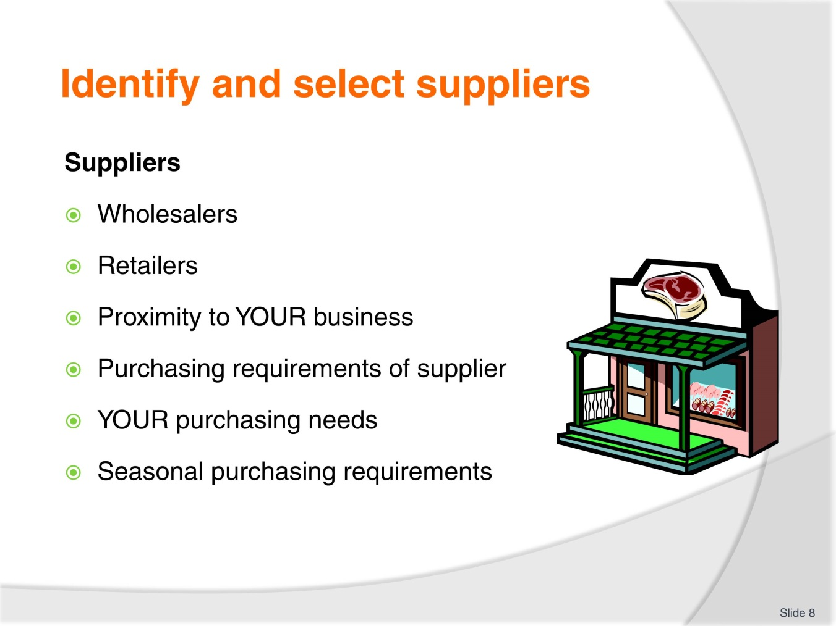
Slide No | Trainer Notes
Trainer to discuss:
What is the best type of supplier for you to engage?
Needs
Purchasing requirements
Delivery requirements.

Slide
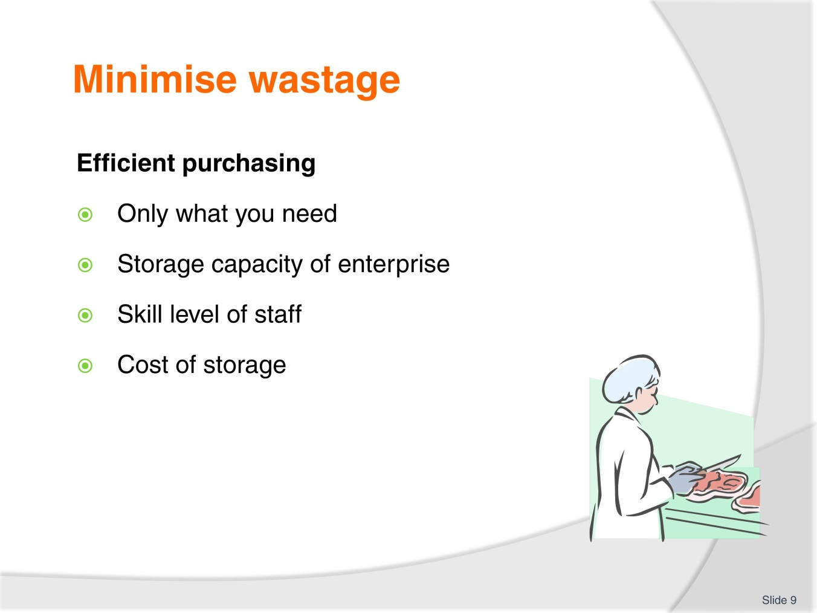
Slide No | Trainer Notes
Trainer to discuss:
Purchase only what you need.
- Pointless buying the whole bird/animal if you do not have the need for the whole of the carcass
- Do not purchase more because it is cheaper to buy in bulk
Be sure you can store what you purchase
Does the enterprise have the capacity to store what you purchase
Skill level
- Does the staff have the skill level to ‘bone chicken’?
Cost of Storage
- Space
- Electricity to run equipment.

Slide
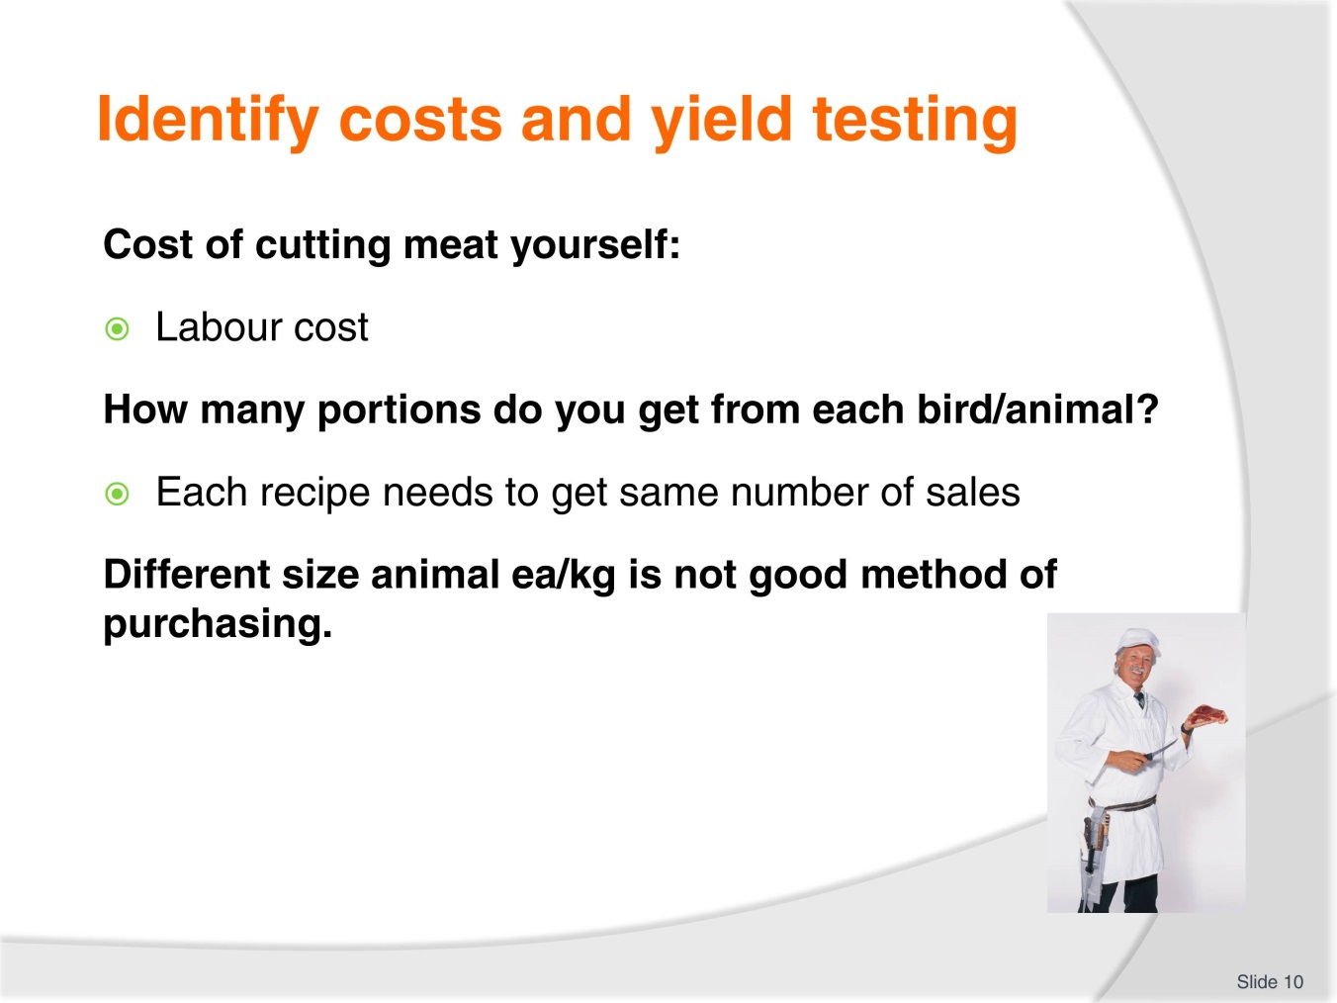
Slide No | Trainer Notes
Trainer to discuss:
Each cook needs to be able to apply cost to recipe to make sure that profit margins are maintained.
25-35% food cost: Industry average

Slide
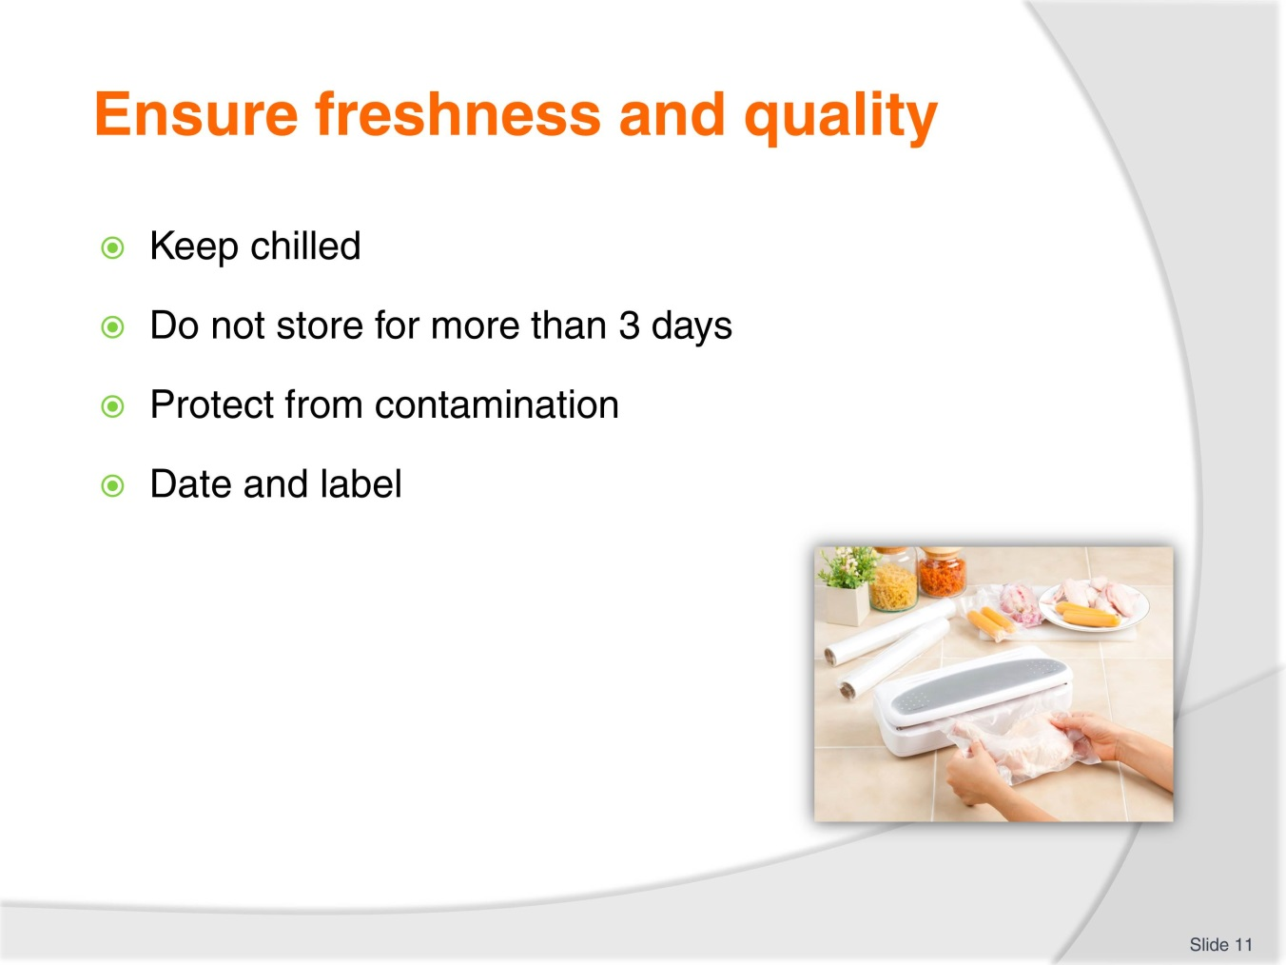
Slide No | Trainer Notes
Trainer to discuss following points with students:
Purchase only what you need
Store chilled
Cover and label food
First in First out proc.
Trainer to check on Work projects of Students

Slide
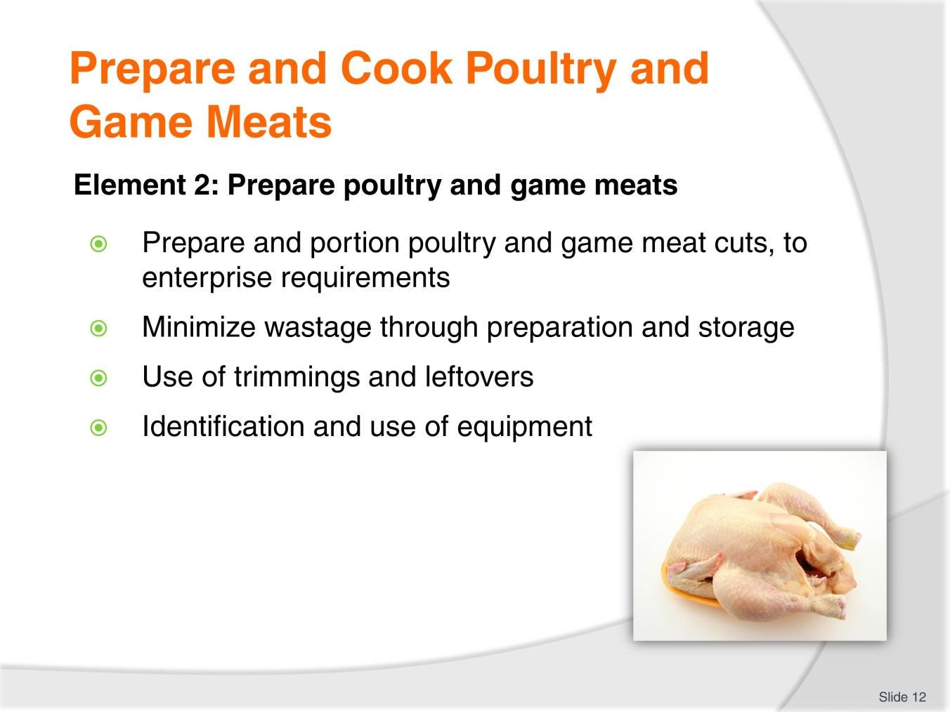
Slide No | Trainer Notes
Trainer to discuss performance criteria required tor Element 2
The element is the skill
To assess competency in the skill; the performance criteria is used to outline activities that can be used to assess competency.
The trainer should relate how the performance criteria is related to the element

Slide
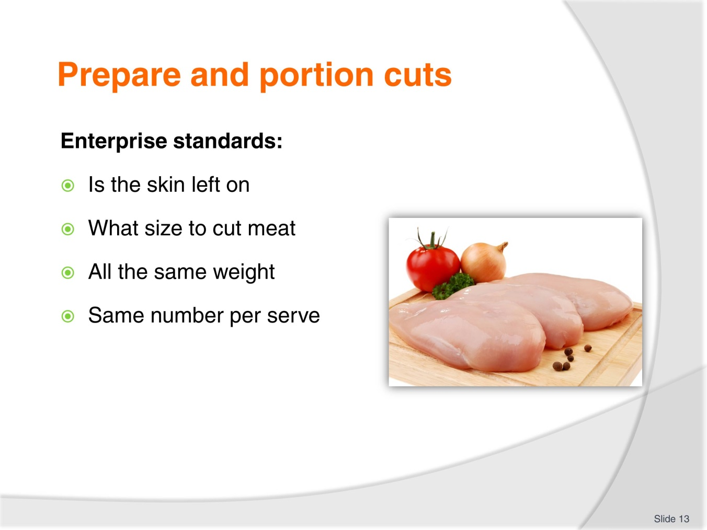
Slide No | Trainer Notes
Trainer to discuss:
What are the standards with each enterprise?
How many pieces in a serve?
How heavy?

Slide
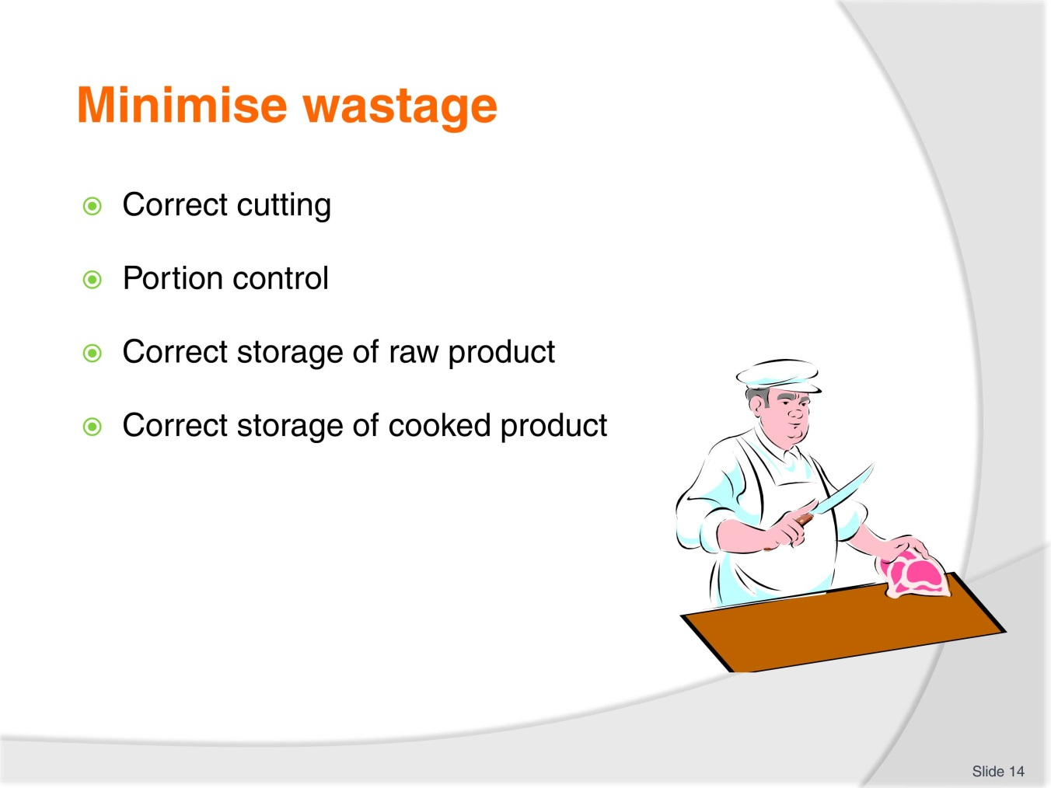
Slide No | Trainer Notes
Trainer to discuss:
Control in preparation is important to minimise wastage
Skill level needs to be adhered to.

Slide
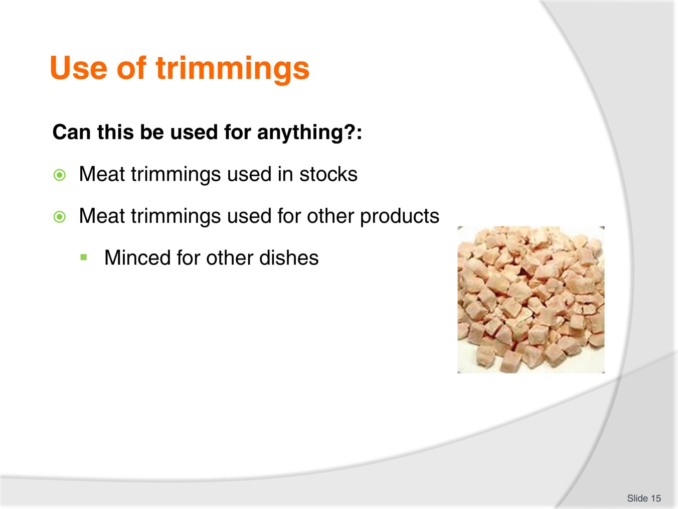
Slide No | Trainer Notes
Trainer to discuss:
Value adding to leftover product to generate income to enterprise.

Slide
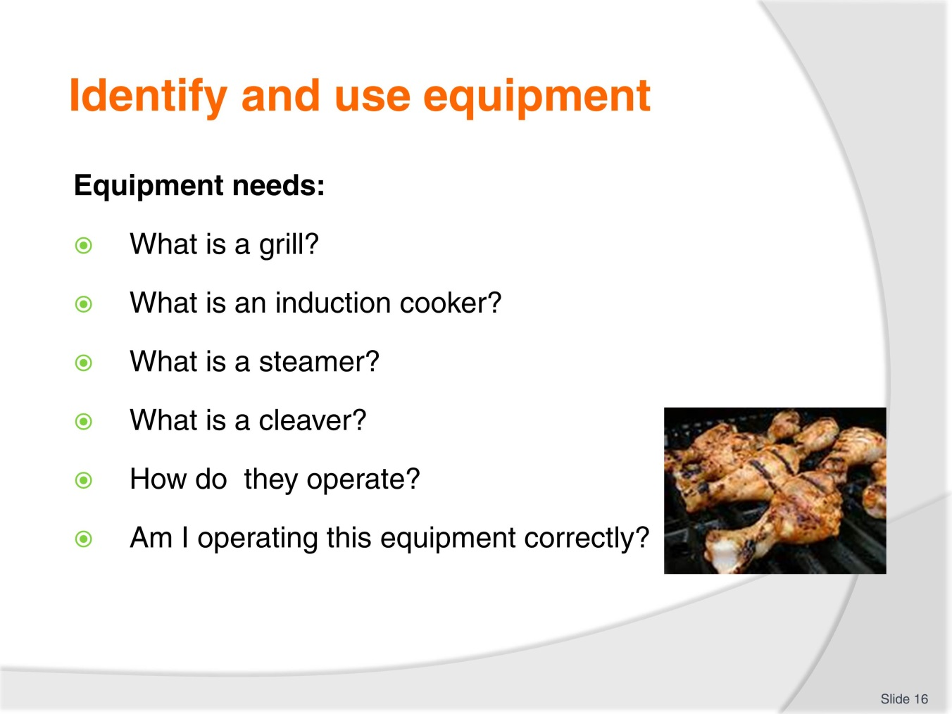
Slide No | Trainer Notes
Trainer to discuss:
To be able to cook specific dishes the cook needs to be able to carry out all the processes.
If the grill cannot be operated correctly the losses will occur:
Induction cooking
Sous vide cooking.
New methods of cooking mean new methods equipment, new skill needed by staff.
New equipment???
Staff need to be trained:
To prevent injuries and
To prevent loss of product due to lack of knowledge in how equipment operates.
Check students progress with work projects.

Slide
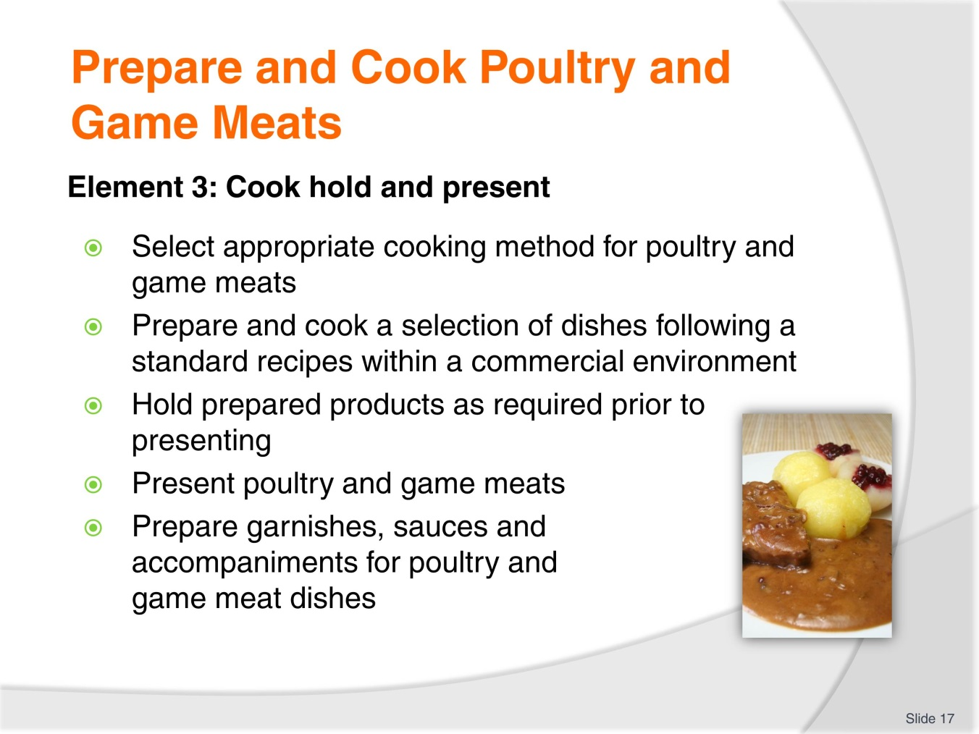
Slide No | Trainer Notes
Trainer to discuss performance criteria required for Element 3
To prove competency in Prepare and Cook poultry game meats the student has to be able to; Cook; Hold and Present these meats.
Cook; apply heat to make meats more easily digestible for humans.
Hold; to keep food until it is required to serve to customer; Normally it is held hot but it might have to be held cold; depending on the recipe.
Present; serve to customer; how the meat is placed onto the plate.
The Students need to be able to:
Select appropriate cooking style for any particular poultry of game meat
Prepare a selection of dishes following standard recipes
Hold these dishes until required for service
Present these selection of poultry and game meats
Prepare garnishes
Prepare sauces
Prepare accompaniments.

Slide
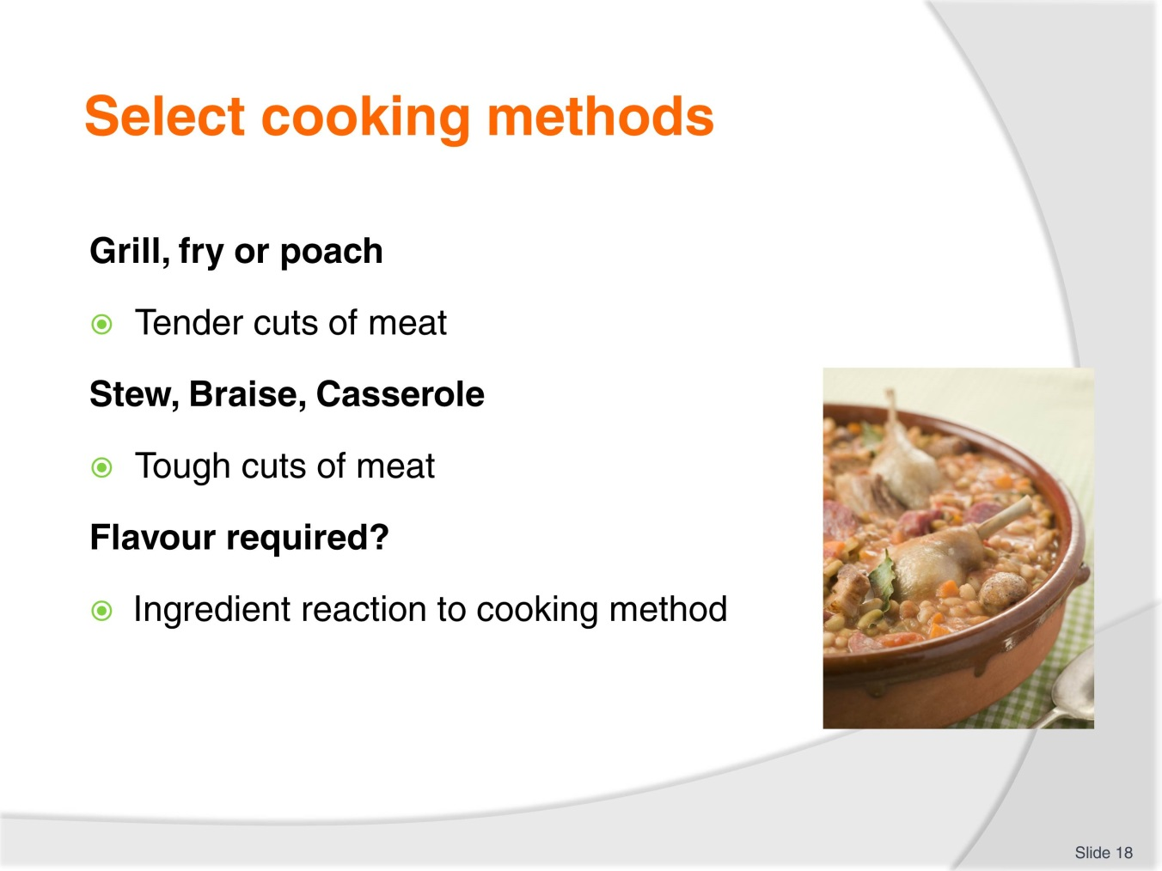
Slide No | Trainer Notes
Trainer to discuss:
Method of cooking will affect the eating quality sensation
Is the meat being grilled. Is it being marinated before grilling?
Is there sugar in marinade? If so, it will burn. Change heat setting?

Slide
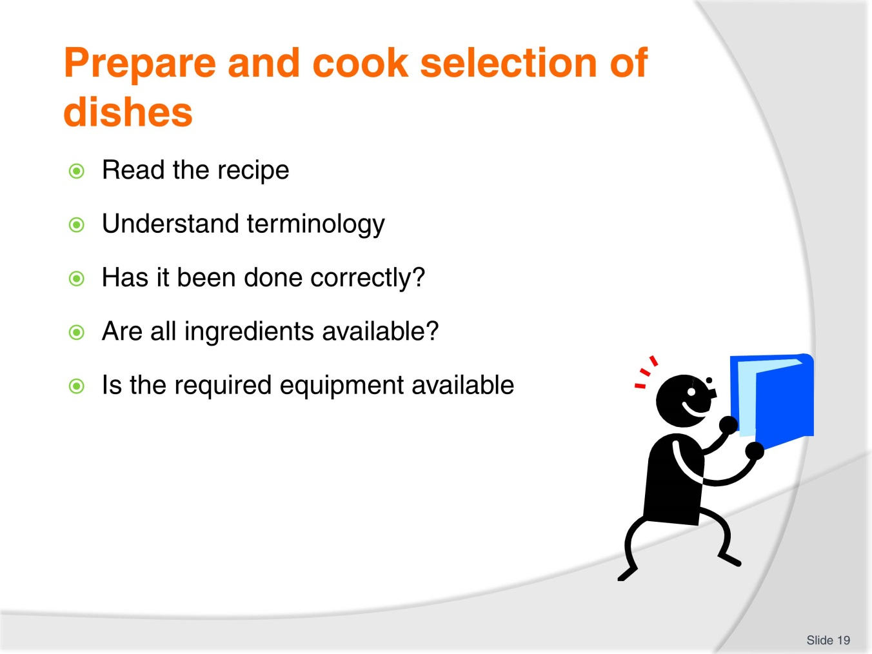
Slide No | Trainer Notes
Trainer to discuss:
Being prepared is half the job done
Has the recipe been read and understood?
What was the end product like?

Slide
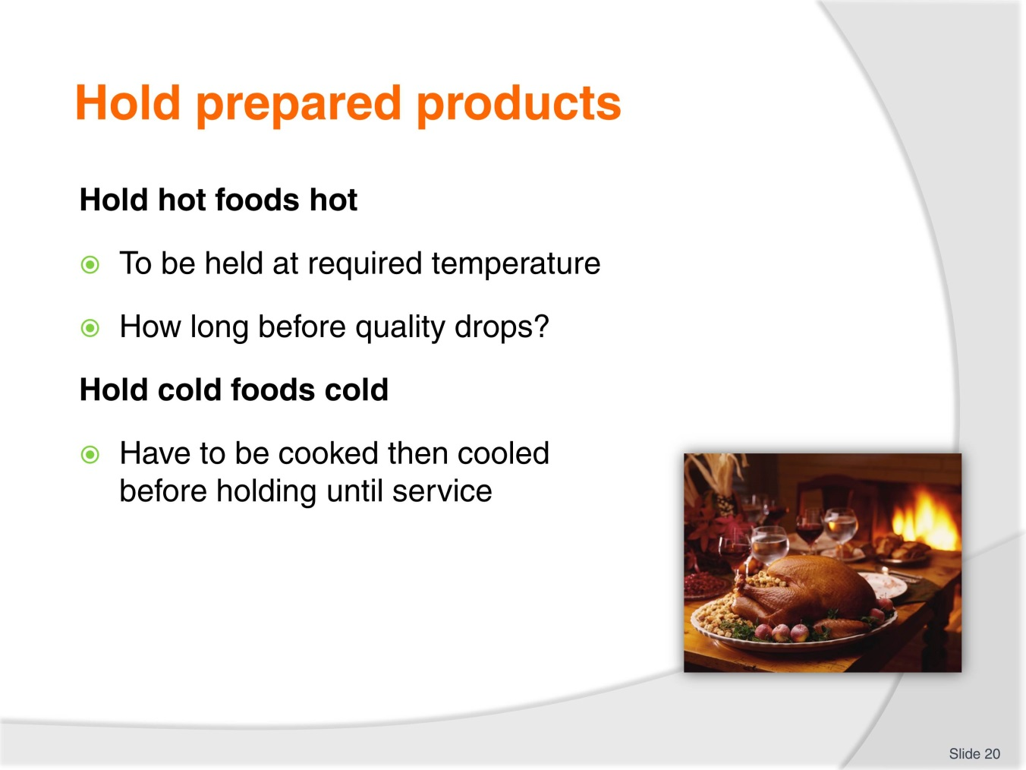
Slide No | Trainer Notes
Trainer to discuss:
Foods need to be held at the required temperature
To maintain QUALITY
To maintain FOOD SAFETY.
Food QUALITY and Food SAFETY go together
Keeping food hot for too long will dry it out but not make it unsafe to eat.
As it is kept hot for too long it dries out and becomes less appetising to eat.

Slide
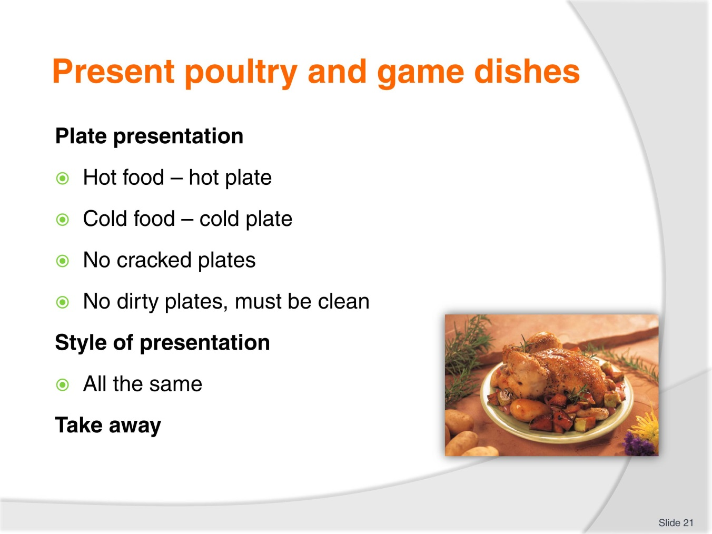
Slide No | Trainer Notes
Trainer to discuss:
How food is presented will add to dining experience
Badly presented food will ruin excellent cooking and diminish the experience
Portion control: all need to be the same size.

Slide
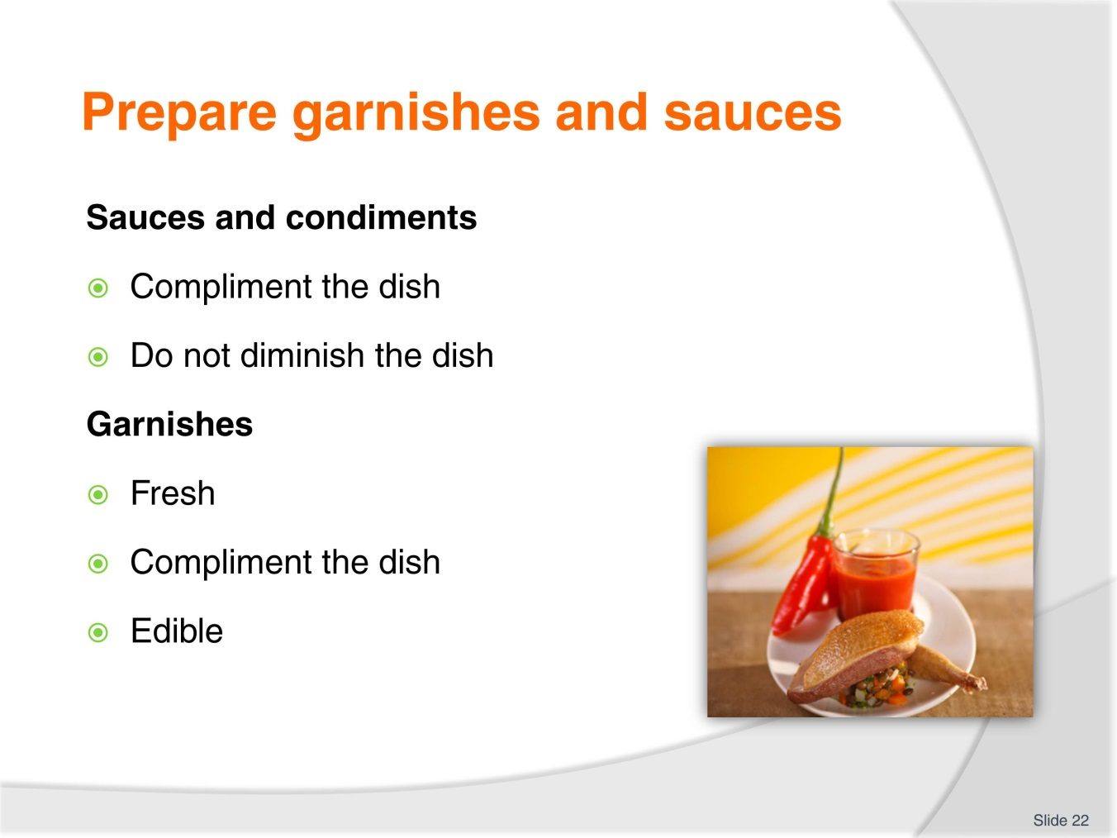
Slide No | Trainer Notes
Trainer to discuss:
Finer points of above
Check students progress on Work projects.

Slide
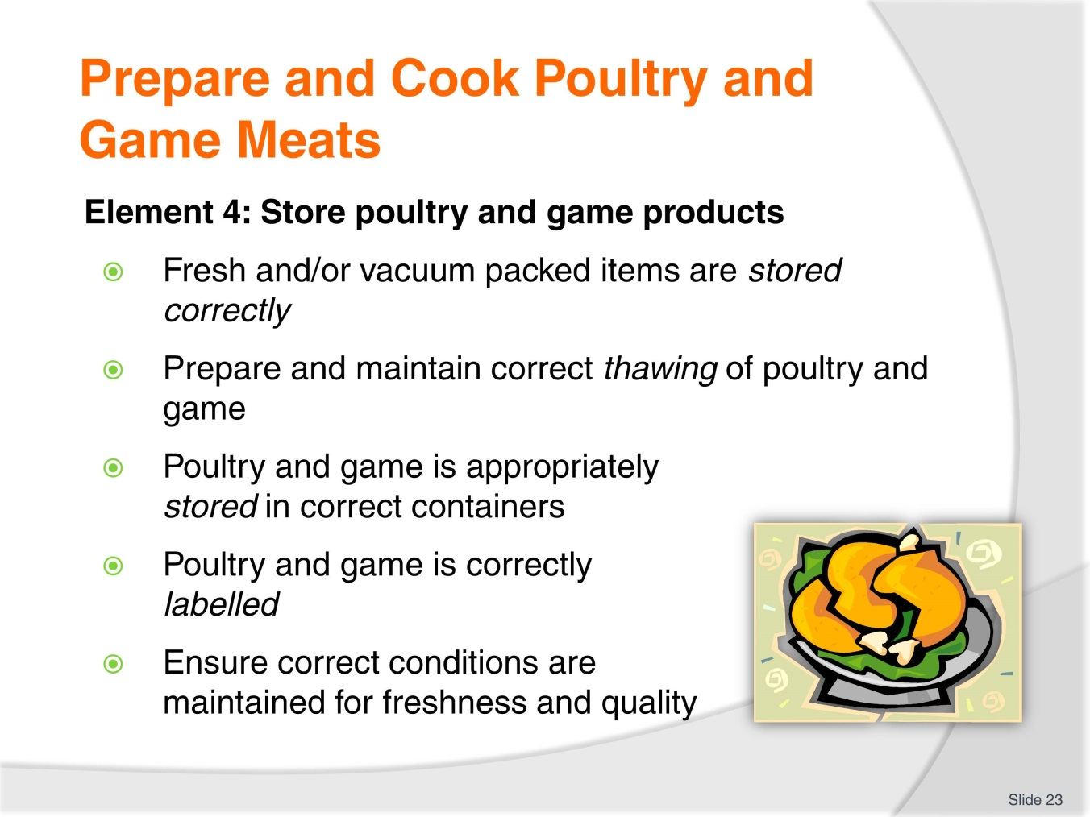
Slide No | Trainer Notes
Trainer to discuss performance criteria of this element with students:
To prove competency in Prepare and Cook poultry game meats the student has to be able to
Store poultry and game products
The students need to be able to:
Fresh and/or vacuum packed items are stored correctly
Prepare and maintain correct thawing of poultry and game
Poultry and game is appropriately stored in correct containers
Poultry and game is correctly labelled
Ensure correct conditions are maintained for freshness and quality.

Slide
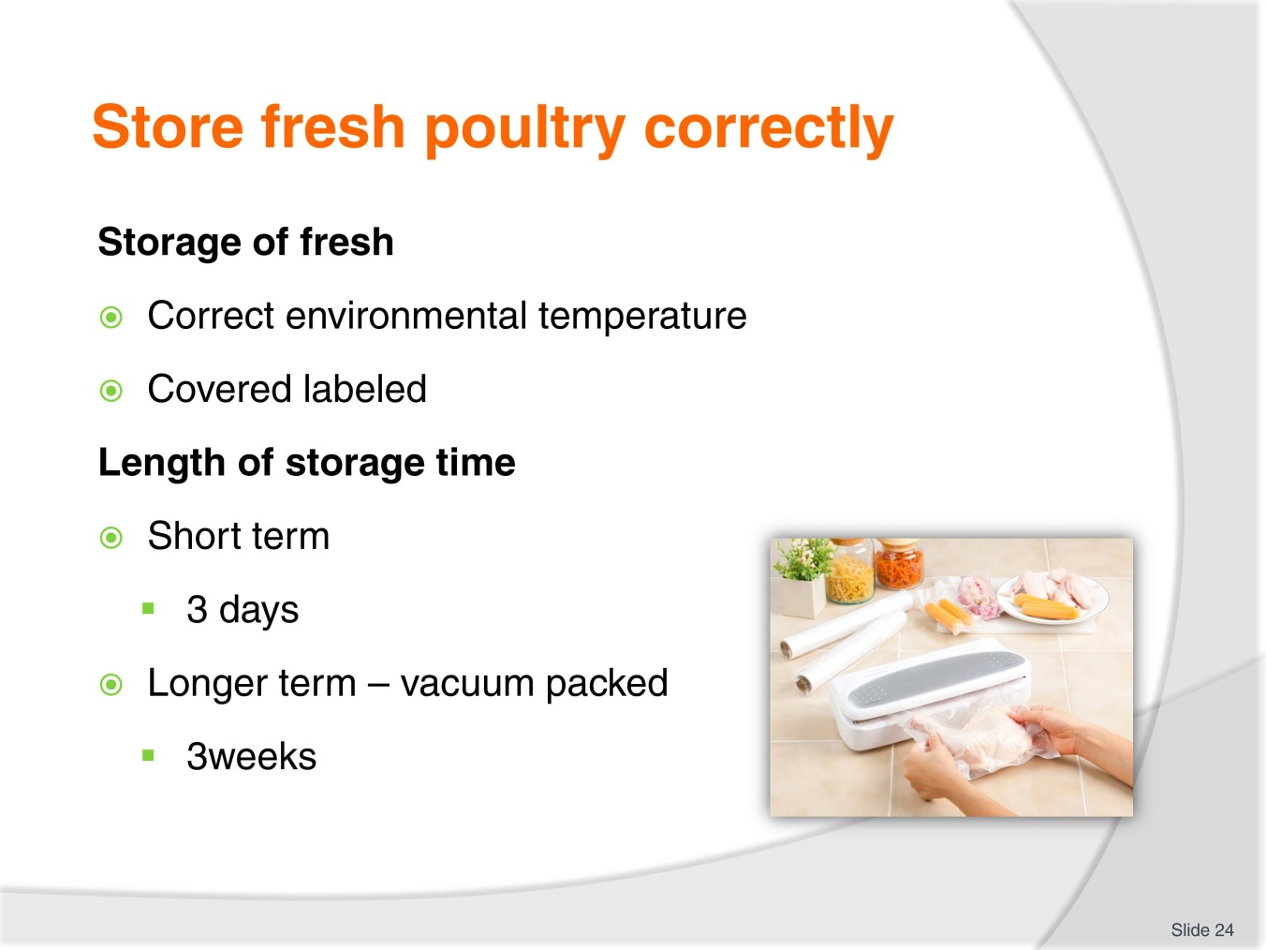
Slide No | Trainer Notes
Trainer to discuss:
Practicalities and difficulties of storing high risk products like fresh meats from poultry and game.

Slide
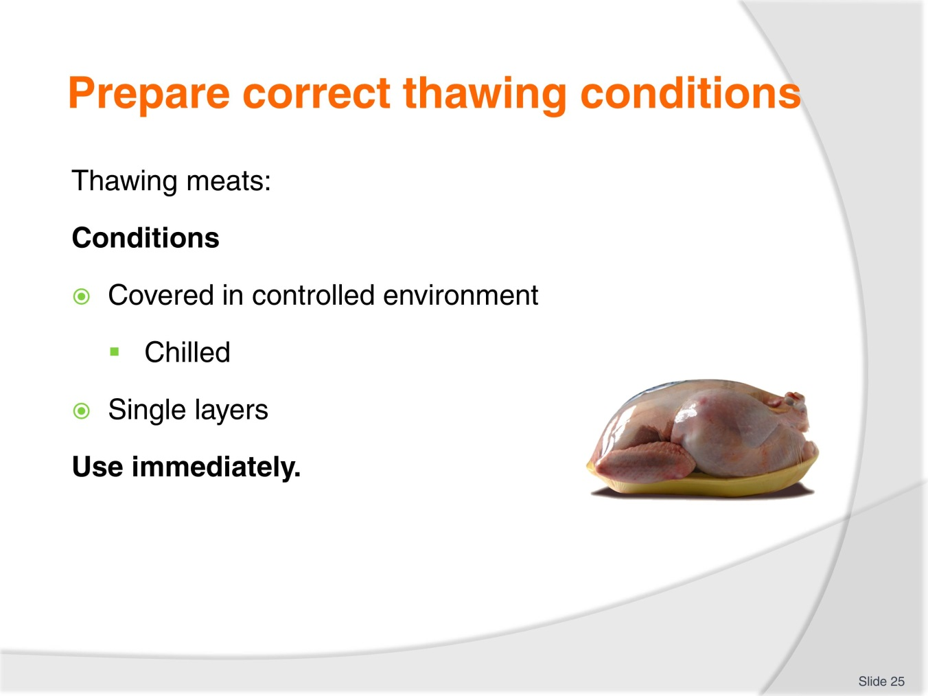
Slide No | Trainer Notes
Trainer to discuss:
Problems with thawing frozen meats in controlled and uncontrolled environment

Slide
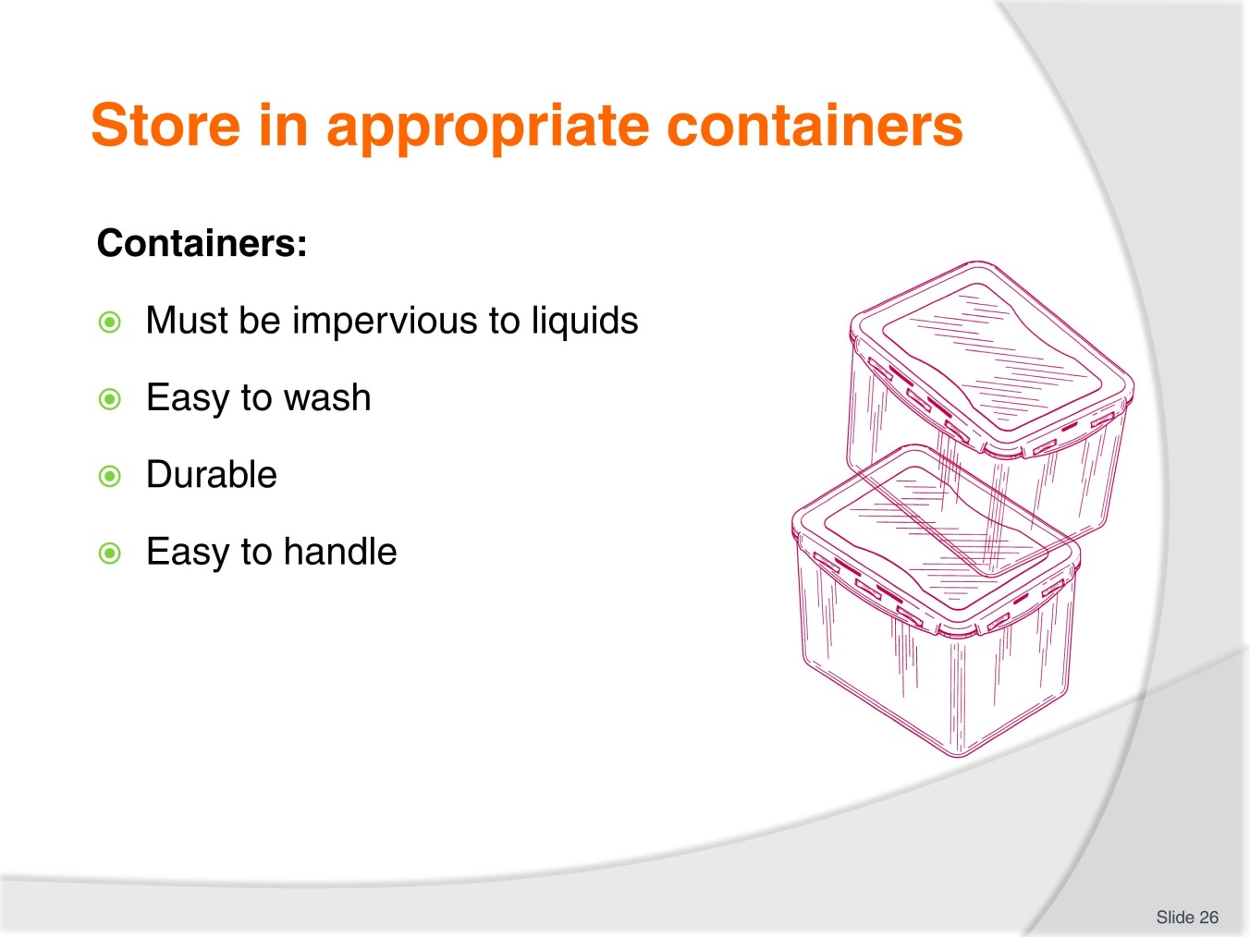
Slide No | Trainer Notes
Trainer to discuss:
Benefits of having containers in good condition
Easy to clean
Lightweight
Uniform sizes
Easy to cover.

Slide
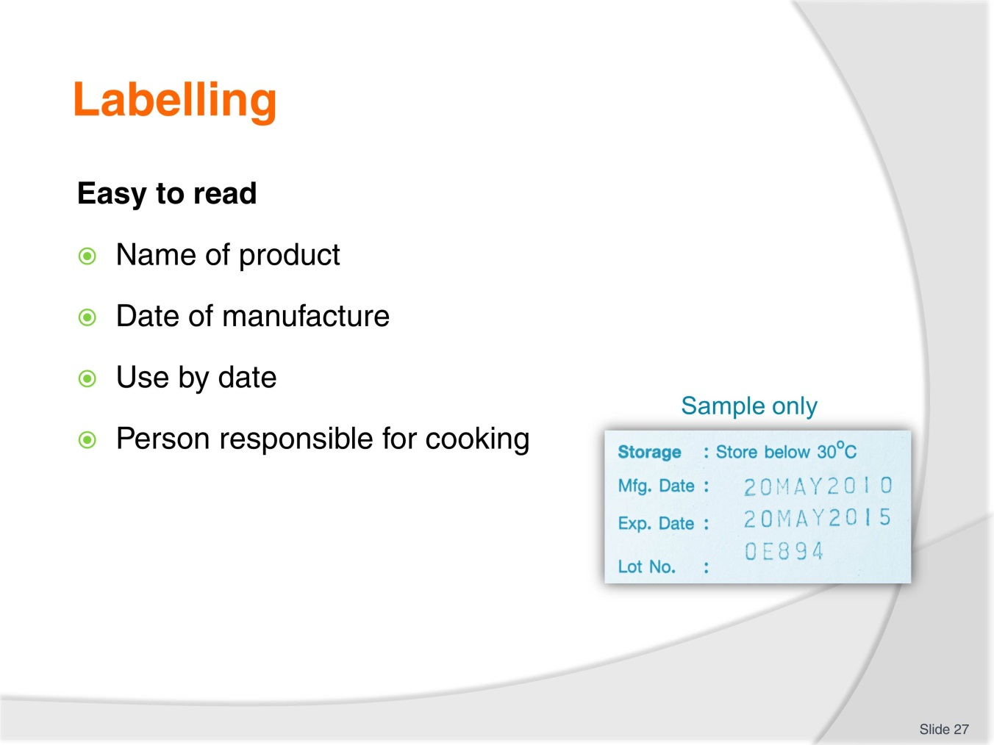
Slide No | Trainer Notes
Trainer to discuss:
Requirements of good labelling

Slide
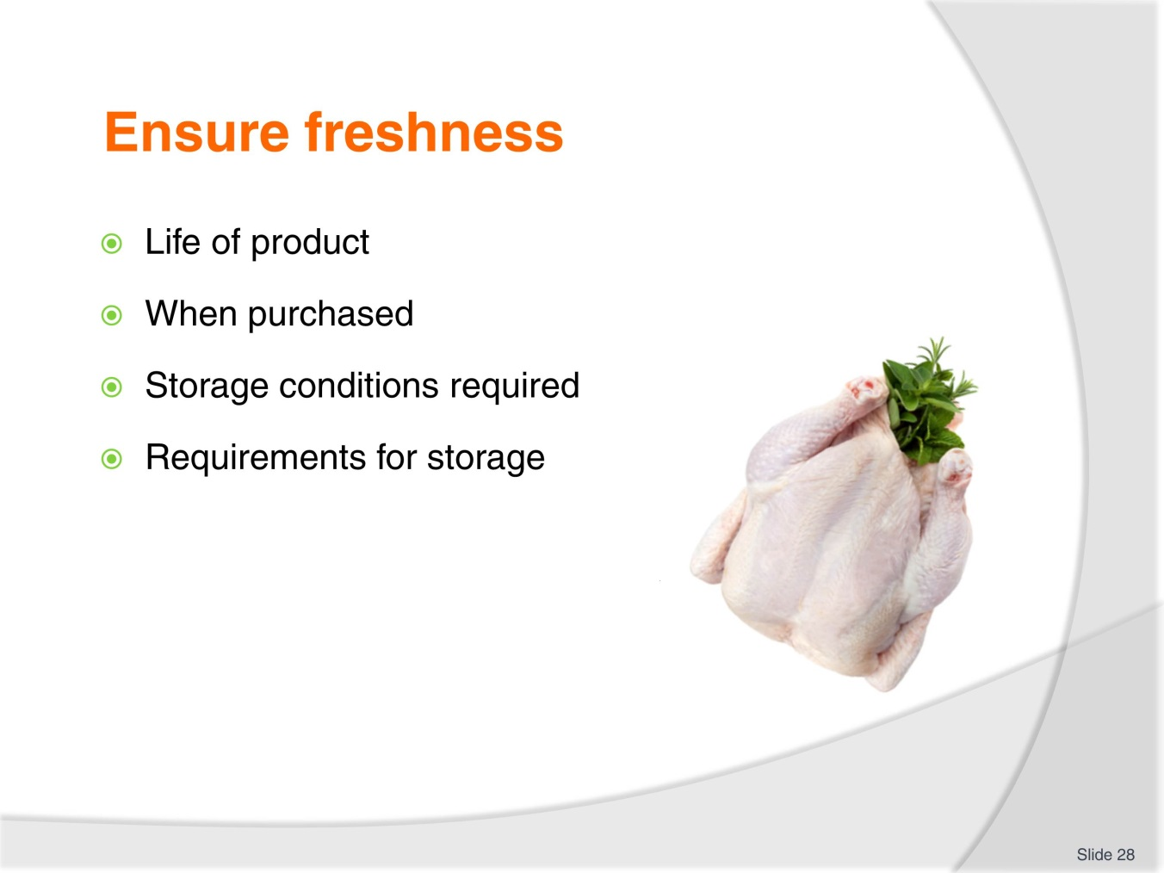
Slide No | Trainer Notes
Trainer to discuss:
Salient point in how to ensure the freshness of product:
Fresh
Cooked
Long term and short term.
What is needed to deliver product to customer in optimum condition.

Slide

Slide No | Trainer Notes
 | Thank you

Cookery practical classes: Recommended training equipment
The equipment and kitchen consumables required for the delivery of practical cookery training classes are listed below, in the following categories:
A Items of equipment which should be available for trainer and student use in the training kitchen.
B The cleaning equipment and cleaning products which should be available in a cleaning room located adjacent to the kitchen, so that students can clean down to leave the kitchen in “as found” condition at the end of each class or session.
C Consumables other than foodstuffs which need to kept in the kitchen and available for everyday use in each class or session.
D The items required by each student which would make up their own individual use kit of tools and small equipment.
A: Equipment in the training kitchen:
Commercial cooking stove 4 burner minimum  Stainless steel workbench  Stainless steel sinks  Dishwasher  Refrigeration  Freezers  Cooking pots, multiple sizes  Lids for pots  Frypan  Woks  Chinois of various sizes  Measuring jugs  Mouilis | Food processors  Ramekins  Sieves for dry ingredients  Deep fryers  Steamers  Weighing scales  Baking trays  Roasting dishes  Chopping boards for preparation  Gas fire lighters, cigarette lighters not recommended  Tongs for handling foods  Spiders for handling deep fried foods
B: Cleaning equipment and consumables:
Detergent  Scrubbing brushes  Scourers  Sink plugs  Brooms  Shovel and small brooms | Floor mops  Mop buckets  Wet and dry vacumns  Detergent  Hand dishwashing detergent  Paper hand towel
C: Consumables (non-food) to be available in the kitchen:
Silicon baking paper  Plain white butchers paper  Greaseproof paper  Aluminium foil | Plastic wrap, clear  Plastic sheeting clear  Product boxes of various required sizes  Doyleys as required
D: Student equipment kit should include:
Chefs knife 21 cm  Boning knife 15cm  Paring knives 9cm  Sharpening stone  Honing steel 30cm  Pallet knives  Wooden spoons 3  Whisk 30cm 1  Vegetable peeler  Pastry brush | Piping bags  Piping tubes, various sizes  Spatula, flexible  Tongs  Digital thermometer  Tea towels 6  Cutlery set  Scissors  Fine strainer  Carry case for equipment

Instructions for Trainers for using
PowerPoint – Presenter View
Connect your laptop or computer to your projector equipment as per manufacturers’ instructions.
In PowerPoint, on the Slide Show menu, click Set Up Show.
Under Multiple monitors, select the Show Presenter View check box.
In the Display slide show on list, click the monitor you want the slide show presentation to appear on.
Source: http://office.microsoft.com
Note:
In Presenter View:
You see your notes and have full control of the presentation
Your trainees only see the slide projected on to the screen
More Information
You can obtain more information on how to use PowerPoint from the Microsoft Online Help Centre, available at: http://office.microsoft.com/training/training.aspx?AssetID=RC011298761033
Note Regarding Currency of URLs
Please note that where references have been made to URLs in these training resources trainers will need to verify that the resource or document referred to is still current on the internet. Trainers should endeavour, where possible, to source similar alternative examples of material where it is found that either the website or the document in question is no longer available online.

Appendix – ASEAN acronyms
AADCP | ASEAN – Australia Development Cooperation Program
ACCSTP | ASEAN Common Competency Standards for Tourism Professionals
AEC | ASEAN Economic Community
AMS | ASEAN Member States
ASEAN | Association of Southeast Asian Nations
ASEC | ASEAN Secretariat
ATM | ASEAN Tourism Ministers
ATPMC | ASEAN Tourism Professionals Monitoring Committee
ATPRS | ASEAN Tourism Professional Registration System
ATFTMD | ASEAN Task Force on Tourism Manpower Development
CATC | Common ASEAN Tourism Curriculum
MRA | Mutual Recognition Arrangement
MTCO | Mekong Tourism Coordinating office
NTO | National Tourism Organisation
NTPB | National Tourism Professional Board
RQFSRS | Regional Qualifications Framework and Skills Recognition System
TPCB | Tourism Professional Certification Board







